34 Curtis Adeniyi Jones Close,
Gbajumo, Off Adeniran Ogunsanya,
Surulere, Lagos.
Tel: 07061287117

13th February, 2017.
The Principal,
Federal Science and Technical College,
Doma,
Nasarawa State.

Dear Madam,

CompuWorks IT Academy Students Bill Payment

Herewith is an invoice for payment of CompuWorks IT Networking Academy for Second Term
(January - April 2017).

S/n | Description | No of Students | Unit cost per Student | Amount
 | CompuWorks IT Academy Training | 1008 | 2000 | 2,016,000
Total |  |  |  | ₦2,016,000

Account Details:

Bank: Heritage Bank account
Branch: Marina
Acct No: 5100011836
Sort Code: 030150027
Name: CompuWorks Cisco Networking

For: CompuWorks

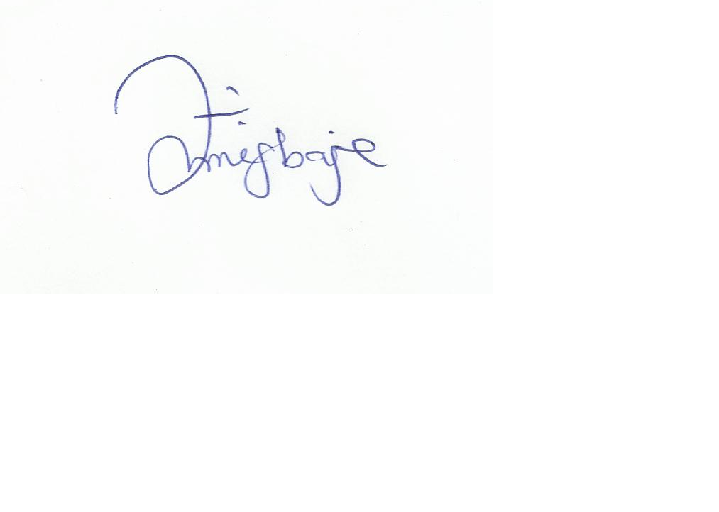
Joyce Megbaje
Project Manager
Jmegbaje@gmail.com
07061287117

